# 2.0 Introduction

# 2.1 Grading system

# 2.2 History of grading scheme

# 2.3 Advantages and Disadvantages of Grading System

# 3.0 Grading of higher education

# 3.1 GPA system

# 3.2 CGPA system

# 3.2.1 Variation of CGPA scale in different countries

# 4.0 The implementation of grading system in Multimedia University

# 4.1 Ways to calculate credit hours

# 4.2 Calculation of GPA and CGPA

# 4.3 Effects of students on tracking their own academic performances

# 

# 

# 

# 

# 

# 5.0 Time management

# 5.1 Importance of time management

# 5.2 Impact of time management on student’s academic achievements.

# 5.3 Usage of timetable

# 5.3.1 Advantages of using timetables management system

6.0 Conclusion

# 2.0 Introduction

To have well understanding on this project title, some related topics are found and researched based on the project title, Planner Assistant which can assist student in different aspects. These topics which are selected will be clearly explained in this literature review.

First of all, grading system is a common topic in education. This is because every academic system must have their own grading system. After that, the basic research of grading system is continued with its history and also advantages and disadvantages of the grading system. Then, there is also a deep research on higher education grading to allow people to get more understanding of grading system. In higher education like college or university, their grading is calculated with GPA and CGPA. Therefore, these two topics are included under the higher education grading. Under the topic of CGPA, there is variation of CGPA scale in different countries because different countries use different CGPA scale. On the other hand, the topics of the implementation of grading system in Multimedia University are a must to have in this project because it is done by the students in Multimedia University and its purpose is to help MMU students get to know their educational performance based on itself. The implementation of grading system in Multimedia University includes the minimum credit hours that is required for foundation, diploma and degree, the calculation of GPA and CGPA, and the effects of students on tracking their own academic performances as well. Besides, the topics about time management are also considerable and researchable on individuals’ academic. Therefore, the importance of time management, impact of time management on student’s academic achievement, the usage of timetable as well as the advantage of using time management system are included in this literature review.

# 2.1 Grading System

Reddy. (2018) defines grading system in education is a system that is used to assess the educational performance of a child which is entirely based upon points alone. Grading system does not provide an opportunity to make the child think out of the box or freely develop the thinking about any inkling of an idea or get involved with any of the intellectual speculation. But still, this method is widely regarded in many of the schools across the world and is kept as a strong and a viable medium to adjudge a child’s grasping and reciprocating ability by grading them. The primeval type of appraisal was by the marks where the marks for all the questions were totaled to get grand total marks. Grading system does not provide an opportunity to make the child think out of the box or freely develop the thinking about any inkling of an idea or get involved with any of the intellectual speculation.

# 2.1.1 History of Grading Systems

According to Lassahn. (2017), on Before Grades, universities have always evaluated students, but the modern grading system did not always exist. In fact, in the 18th century, there was no standardisation on evaluating students, and certainly no means by which student performance at one institution could be easily compared with student performance somewhere else.

The First Grades, it was also at Yale University that a system resembling current grading system was first used. In the first quarter of the 19th century, Yale kept student information in what it called a Book of Averages; this book also sometimes discussed rules and procedures for setting down exam results. The book mentioned the practice of recording an average of each student's marks--a procedure still used in figuring course grades--and also mentioned marking on a 4-point scale. While there is no mention this early of the letter grades we know today, the 4-point scale is probably the precursor of today's grade point average. Numerical scales also were used elsewhere, but they varied by institution. College of William & Mary used a 4-point scale, with 1 as the best and 4 as the worst. Harvard College used both a 20-point and a 100-point scale. Yale apparently experimented briefly with a 9-point scale before returning to the 4-point scale. Lassahn. (2017).

Letter Grades, in the last half of the 19th century, colleges continued to study with various scales for evaluating students and also for grouping and classifying them. Some systems evaluate students individually. For example, the University of Michigan's marking system in 1895 provided students with one of five marks on exams: passed, incomplete, not passed, conditional or absent. Other systems were attempts to rank or order the entire student body, or all students in a class, by placing them into categories, divisions or percentages, such as Harvard's 1877 system that placed students in one of six "divisions" using a grading scale of 100. Division I was students earning 90 to 100 on the evaluation scale. These systems might not have averaged student performance to create comparative ranks, what people call grading on a curve. It was in 1897 at Mount Holyoke College that letter grades tied to a numerical or percentage scale were first used. The college assigned students in percentages 95 to 100 an A, 85 to 94 a B, 76 to 84 a C, 75 a D, which is the lowest passing grade, and anything below 75 an E, which indicated a failing grade. Modern F grade was not used, but this system was the beginning of the relatively standard grades today. Lassahn. (2017).

Early K-12 Grades, it was in the first part of the 20th century that American elementary and high school education also began using standardised grading systems. This period corresponded with a huge increase in the number of students; compulsory attendance laws had been passed during this period, and the number of public high schools increased from 500 to 10,000 between 1870 and 1910. These changes made the use of written, descriptive reports less practical, and high schools increasingly began using both percentage and letter grades to evaluate students. In 1912, Daniel Starch and Edward Charles Elliott, two researchers from Wisconsin, examined the reliability of percentage grades and found that there was immense variation from teacher to teacher in both the criteria used to assign grades and the grades themselves. This variation and the desire for more standard grades, has led to an overall move away from point scales with a large range to a smaller types of grade scales. Lassahn. (2017).

Based on Lassahn. (2017), the grading system controversies while grade scales in the U.S. are fairly standard, debates and questions about grading continue today. There are similar questions about variability, because grading can be a subjective process, as well as more philosophical questions about the relationship of grades to learning. Finally, even the grade scale itself is not exactly the same at all schools. One of the largest concerns about variability is grade inflation, the phenomenon in which average grades at private schools are higher than at public schools. While some claim that this discrepancy is caused by private schools' greater selectivity in admissions, implying the student body is smarter at private schools, data collected by Stuart Rojstaczer, an American writer, show that even when schools have the same degree of selectivity, private schools have higher grade point averages than public schools. Faculty members such as Harvey C. Mansfield, an American political philosopher, have publicly complained about the pressure to raise grades beyond what is deserved. One reason for grade inflation is probably pressure from students who are concerned about their grades and their future career prospects. Educators worry that grades can make students more focused on credentials and less on actual learning. It is also the case that grades can take the place of more substantive and individualised assessments; there are different ways of determine whether students are learning, and grades are not always the best method. There is also some debate about whether the practice of grading on a curve is useful in assessing student learning. Finally, while it is true that a standardised grading scale can be necessary in a world in which students move from school to school and state to state. In addition to variations in grade inflation, means that the same student might receive a different grades at different institutions, schools also vary in their use of the plus and minus system, and some use a point system rather than letter grades.

# 2.1.2 Advantages and Disadvantages of Grading System

Wilson. (2017) states that the advantages of grading system is students nowadays will get accessed on the basis of assignments, objective and subjective tests, presentations, quizzes and final term paper. Furthermore, grading system let students to identify their strength and weaknesses. Teachers grade students’ skills of writing, reading and listening, which means that students can easily know their weakness through the assigned grades and work on them to improve overall performance. Thus, the grading system has made studies easier in many ways. The students who only want to pass can make lesser efforts to get a passing grade. And for students who want to score higher can divide the effort per task and achieve the overall targeted grade easily. Kamra. (2017) shows that because each letter grade generalises a certain percentile range, students may strive simply to attain the lowest percentile associated with the target grade. For instance students can attain B by achieving percentages ranging from 80 to 89. Other accuracy issues such as attendance, class participation and late assignments can have a big impact on a student's final letter grade. Grading system also has some disadvantages such as decreased performance because students tend to perform less as they know that they will achieve the targeted grade even by making a few mistakes. For instance, if a student targets the grade A that involves the range from 90% to 100%, he will know that even if he scores 90, grade A will be assigned hence he does not require to score 95 to 100. Grading system also demotivates the students who perform higher because they stand equal to those making less efforts. Thus, grade A will be assigned to all those scoring from 90 to 100. So, students who made no mistakes and those who made a few, all will stand equally at one grade. Other than that, students have become more lethargic as the grading system has divided the marks among different tasks such as assignments, presentations and final exams. They score enough in assignments and projects and become less active in final exams. Gross. (2017) asserts that grading system does not show the knowledge gained by students. Attaining grades in examination does not clearly show the amount of actual knowledge gained by students. Some students are actually weak at writing and are not able to showcase their knowledge merely through an examination. Besides, the grading system fails to give a clear view of knowledge of the students.

# 2.2 Grading of Higher Education

The grading of students in higher education is important for some reasons, not least because it can strongly influence whether particular career opportunities can be pursued. In contemporary higher education systems, students are expected to demonstrate not only high standards of academic achievement but also their broader employability. Many aspects of employability are difficult to grade, however, and some students may lose out because their particular strengths are not sufficiently acknowledged by current summative assessment practices. Drawing on evidence from Australia, the UK and the US, Grading Student Achievement in Higher Education appraises the way in which summative assessment in higher education is approached and demonstrates that current practices are of questionable robustness. Yorke. (2007).

# 2.2.1 GPA System

GPA, or Grade Point Average, is a number that indicates how high a student scores in their courses on average. It’s meant to score students usually on a scale between 1 and 4 during their studies, and shows whether their grades have been high or low overall in their classes. This number is then used to assess whether the student meet the standards and expectations set by the degree programme or university.In the same way that professors and instructors give students a grade to evaluate students’ progress or success in their course. Grade Point Average is similarly a score used to evaluate students’ success during the entirety of their degree programme. It’s an average number that shows what a student typically scored in classes throughout the semester, term, and year. Students’ GPA can go up and down throughout the time at the university, and will change according to how much they improved on overall grades or, in some cases, how much the students fell behind. Kevin. (2017).

# 2.2.2 CGPA System

Rashadul. (2014) contends that a student’s cumulative grade-point average is the weighted mean value of all grade points he or she earned by enrollment in university courses. Cumulative Grade Point Average (CGPA) refers to the overall GPA, which includes dividing the number of quality points earned in all courses attempted by the total degree-credit hours in all attempted courses. The semester or term GPA is your Grade Point Average for that one term or semester. The Cumulative GPA is the grade point average of a student for all attempted courses in the program.

# 2.2.2.1 Variation of CGPA scale in different countries

Ganesh. (2017) found that Universities in the US assess students scholastic abilities in terms of GPA. However, there is no official standardised or uniform grading system there and it is left to the individual university or other regulatory bodies to choose and follow a set method of evaluating their applicants. Commonly, a four-point grading system is followed by universities. This means that a student is graded on a scale from 0 to 4, with 4 being the maximum attainable CGPA. However, some universities have been known to follow a nine or ten-point grading system as well, e.g: Rackham School of Graduate Studies at the University of Michigan, till 2013, after which they also switched to the more widely used four-point system.

Calculating CGPA in Germany is very different from the US or India. Germany uses a 5 point system for CGPA calculation of their enrolled students, where 1 is the best and 5 is awarded for insufficient performance. This system is based on the Modified Bavarian Formula. This formula takes into account the best and the least scores possibly attained in the applicant’s native educational system and convert your grade in correlation to these.

In Canada, every university has its own grading system and the parametric is not common across universities or even regions. Students may be advised to report their scores as it is or convert it. Some universities provide guidelines for applicants to make the conversions. For Example, McGill University chooses to give equivalencies to students’ CGPA based on the country on their site.

# 2.3 The implementation of grading system in Multimedia University (MMU)

As established by Institute for Postgraduate Studies Multimedia University. (2011) , below are the implementation of grading system in Multimedia University.

For a taught subject, candidates shall be appraised on two evaluation components, as follow:

1. Final examination, which shall constitute 50% - 70% of the total marks; and
2. Coursework, which includes test, quiz, project, laboratory report etc., and which shall constitute 30% - 50% of the total marks.

Evaluation for subjects that are practical or design-based may be 100% on course work.

The following items pertaining to the grading system shall be determined by the Faculty Board and endorsed by the Senate:

1. Implementation of the open book examination practice;
2. The percentage breakdown for the final examination and coursework; and
3. The breakdown for coursework.

Table 2.1 below shows the scheme mark and grades.

Table 2.1: The scheme of mark and grades

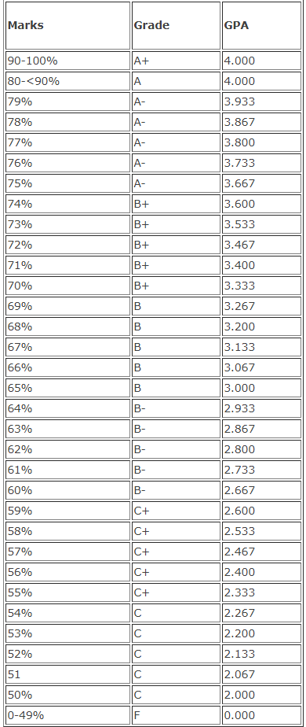

Source: Institute for Postgraduate Studies Multimedia University. (2011)

The following codes shall be used to indicate a candidate's status:

W -Withdrawn - A candidate has withdrawn from a particular subject two (2) weeks prior to the examination.

I - Incomplete - A candidate is not able to attend the examination due to valid reasons approved by the BOE or a candidate has not completed the requirements of the subject but has attained at least 75% attendance at lectures, tutorials and laboratory sessions.

U - Unofficial Withdrawal - A candidate has been absent from the examination without giving any reasons. Equivalent to '0' points and will be included in the computation of the semester grade point average.

AU -Audit Subjects - A candidate has been allowed to audit the subject and has attended at least 70% of the lectures for the subject.

R - Barred from Examination - Equivalent to Grade 'F'

EX - Expelled Candidates

Thesis or Dissertation progress is graded either as satisfactory (S) or unsatisfactory (US).

# 2.3.1 Minimum credit hours that is required for foundation, diploma and degree in MMU

Below are the information about the minimum credit hours that is required for foundation, diploma and degree in MMU by Multimedia University Exam and Records Unit. (2017).

Students are to adhere to the academic load as prescribed below:

**New Student & Students who fall under ‘Follow Programme Structure’**

A student who is in this category is required to register the subjects as prescribed in his programme structure.

**Students who fall under ‘Not Follow Programme Structure’**

A student who is under this category is allowed to register for a maximum number of credit hours as the following:

Table 2.2 shows the minimum credit hour requirement of MMU students.

Table 2.2: Credit hours required for engineering and non engineering students

|  |  |  |
| --- | --- | --- |
|  | Engineering | Non Engineering |
| 14 lecture-week trimester | 18 CH | 20 CH |
| 7 lecture-week trimester | 9 CH | 10 CH |

Source: Multimedia University Exam and Records Unit. (2017).

The above is not applicable to students who are undergoing industrial training or doing final year projects).

**Minimum Academic Load**

All students from both categories are allowed to register a minimum of 12 credit hours for a long trimester and 6 credit hours for a short trimester.

# 2.3.2 Calculation of GPA and CGPA

**Grade Point Average (GPA)** is the average point of a student for a particular trimester computed by multiplying course credits by the appropriate grade-point equivalent. Add the grade points earned in each course to calculate a semester total, and divide this sum by the number of credits taken to determine the semester/session grade point average. Figure 4.1 shows the equation of GPA.

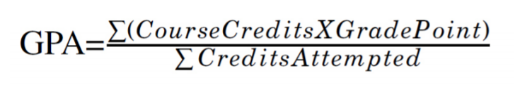

**Figure 4.1 The equation of GPA**

Source: Rashadul. (2014).

Table 4.3 show the gpa calculation method and result

Table 4.3 Calculation of GPA and Result

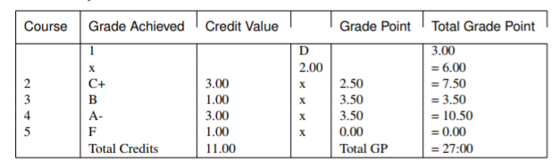

Source: Rashadul. (2014).

Figure 4.2 below Rashadul. (2014).

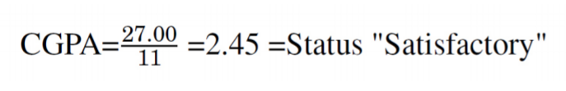

**Figure 4.2 The calculation of CGPA**

Source: Rashadul. (2014).

**Cumulative Grade Point Average(CGPA)** is based on the whole academic years evaluation of performance grade point. Usually, the CGPA is being calculate at the end of the entire academic years. To calculate a cumulative grade point average, total the credit hours and then the grade point from all semesters. Divide the total grade points by the total credit hours.

Below are the Figure 4.3

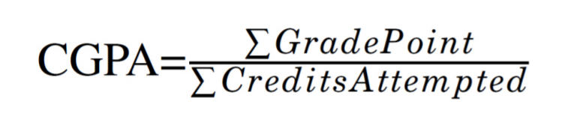

**Figure 4.3: The equation of CGPA**

Source: Rashadul. (2014).

Below are the Table show the cgpa calculation method and result

Table 4.4 Calculation of CGPA and result

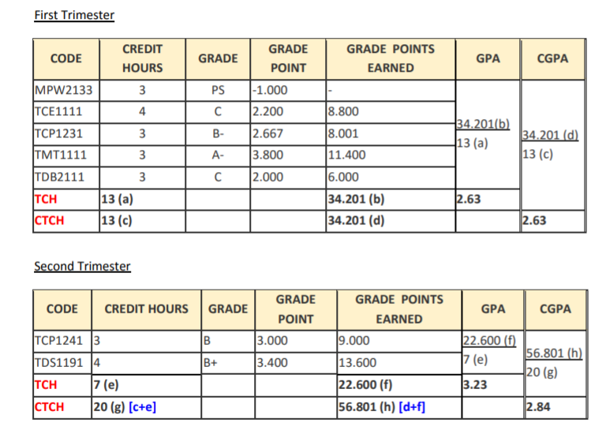

Source: Multimedia University Exam and Records Unit. (2017).

# 2.3.3 Effects of students on tracking their own academic performances

The strategy of tracking student progress on specific learning goals is well supported. For example, Fuchs and Fuchs found that providing teachers with graphic displays of students' scores on formative assessments was associated with a 26 percentile point gain in achievement. Unfortunately, this strategy has not received the attention it deserves. When students track their own progress on assessments using graphic displays, the gains are even higher. Over author’s many years of working with teachers, he have had the opportunity to examine the effects of such an approach. In 14 different studies, teachers had students in one class track their progress on assessments; in a second class, these teachers taught the same content for the same length of time without having students track their progress On average, the practice of having students track their own progress was associated with a 32 percentile point gain in their achievement. In the studies, students recorded their scores on a chart after taking each assessment. Figure 1 shows how a student tracked his or her progress on the topic of habitats using his or her scores on four different assessments. Using a rubric with a rating scale of 0 to 4 to score the assessments, this student began with a score of 1.5 on the first assessment and ended with a score of 3.5 on the fourth assessment. Marzano (2010).

Below are Figure 4.4

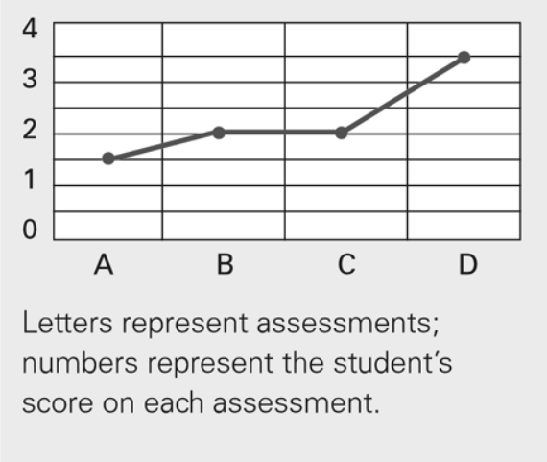

**Figure 4.4: Example of Student Progress Chart**

Source: Marzano, R. J. (2010).

This approach provides two kinds of information for students and teachers. First, the rubric provides a description of the levels of performance that the teacher expects of the students. Second, the graph provides a representation of each student's progression of learning. The combination of these two types of information produces the powerful effect.

# 2.4 Time management

Generally, time management refers to the development of processes and tools that increase efficiency and productivity - a desirable thing in business because good time management supposedly improves the bottom line. Today, the time management definition has broadened to encompass our personal as well as our working lives; good time management also supposedly improves our work-life balance and therefore, our general happiness. This theory, though, is not universally accepted. Sherly Sandberg, the Chief Operating Officer of Facebook said “There’s no such thing as work-life balance, There's work, and there's life, and there's no balance,” Ward (2018).

# 2.4.1 Importance of time management

Time management is important for student personal life and career success. It teaches students how to manage their time effectively and make the most of it. There are few reason that claim time management is so important. Time is a special resource that we cannot store or save for later use. Everyone has the exact same amount of time each day. Time not well used cannot be retrieved. Most people, feel like they have too much to do and not enough time. They blame lack of time for their poor finances, stress, bad relationships, and for not exercising their body. Wise time management can help students find the time for what students desire, and for what students need to do. Moreover, they will become more productive using improved time management skills and tools, and can accomplish more with less effort and time. Time management can help students reduce wasted time and energy, help them become more creative and productive, and enable them to do the right thing at the right time. This will of course lead to more balance and fulfillment in their life. Sasson (2018). Time management is an amazing skill because once we are on top of our life, it gets so much easier to make good decisions. When they are running around trying to put out fires 24/7 it’s nearly impossible to really take a look at all the opportunities that come their way. They would either feel too busy to pursue the good ones or too rushed to say no to the bad ones. If students put the effort into learning how to manage their time better, all of their decisions will improve because of it. Keller (2018).

# 2.4.2 Impact of time management on student’s academic achievement

Time management is very important and it may actually affect individual's overall performance and achievements. However, all of these are related by how individuals manage their time to suit their daily living or to make it flow steadily with their routines. Conducive settings and environment will surely promote positive outcomes to the students, besides having good lectures given by their teachers. Nevertheless, students’ time management can be considered as one of the aspect that can move a student to be a good student. A good time management is needed for students to shine. However, some of the students do not have a good time management skills that has negatively affect their life and their academics. The usage of time by students in higher education institutions is related to their daily routines and activities. Students' time management can also affect stress level of students as they need to cope with their tasks and their personal achievements. Shazia & Saqib (2015).

# 2.4.3 Usage of timetable

The school timetable is a powerful administrative tool. Ideally it should operationalise the aims and objectives of the school by providing an appropriate structural dimension to the curriculum. Stark reality may prevent this ideal relationship from being achieved. Another function served by the school timetable is its allocative role. It performs the important task of allocating a large proportion of the school's resources. The resources of teacher‐time, pupil‐time and room‐space have their use controlled directly by the timetable. The material resources of equipment and supplies, which are largely related to subjects taught, are indirectly controlled. Timetable analysis can therefore serve two purposes. It can reveal the reality of a school's curriculum organization. This reality may be intentional or unintentional. Secondly, it can show where a school allocates its resources, in particular the important ones of teacher‐time and room‐space. Information in these areas should enable school administrators to make better decisions on the school's educational programme and on resource allocation practices to achieve desired aims and objectives. Geoff (1986)

# 2.4.3.1 Advantages of using timetable management system

As established by Hisham (2018), the biggest advantages of digitising the school towards using a timetable management system. Creating a timetable can be a complex task. However, the use of technology can make the task easier, also make result can be achieved in least time. All that the teacher needs to do is to input the data and the artificial intelligence of the school management software would automatically create the timetable, assigning teachers to the students whilst ensuring the optimum use of all resources and school infrastructure such as laboratory hours, play time and library periods. Another advantages is reduce error. Any manual system is subject to human errors. However, using the automatic timetable management system ensures that there is minimal chance for error. Additionally, if there is an error in the input of data, the same can be rectified within minutes, with the simple press of a button. For the school that have multiple standards of classes, with many class division, this error-free method of creating a timetable can prove to be a boon. Moreover, user also get instant notifications if there a changes. Using an automatic system makes it easier for students to get instant notifications in case of any change in timetables such as a change in the time of the class or a change in the faculty taking the class. This ensures that the students are prepared in advance for a change in their daily schedule, thus creating an environment for better learning. Last but not least is the easier customisation according to the brand guidelines of school. Additionally, schools also have the option of customising the brands based on their choice of language, locations, number of schools, number of grades and others. This easy customisation feature helps meet the unique scheduling needs of each school with ease and speed.

# 2.5 Conclusion

In conclusion, Planner Assistant is very useful for most students. It can give students many tools such as grading system, calculation of GPA, CGPA and also time management. Reddy. (2018) states that the grading system is a system that is used to assess the educational performance of a child which is entirely based upon points alone. It allow students to be aware of their own performance in education so that students can improve more in the future. Moreover, students can stay aware of their GPA and CGPA so that student can put more effort in each of the examinations to get better results. Time management is also very important to students because it allow students to accomplish more in a short period of time, this will let students to have more free time. Time management also lets student take advantage of learning opportunities, lowers their stress and it helps them to focus, which will lead to more career success.

References

# 1. Reddy, C. (2018). Grading System in Education: Advantages and Disadvantages. Retrieved from <https://content.wisestep.com/advantages-disadvantages-grading-system-education/>

# 2. Lassahn, N. (2017). History of Grading Systems. Retrieved from <https://classroom.synonym.com/history-grading-systems-5103640.html>

3. Wilson, T. (2017). Advantages and Disadvantages of School's Grading System. Retrieved from <https://taylorwilson.atavist.com/advantages-and-disadvantages-of-schools-grading-system>

4. Kamra, K. (2017). How grading system benefit students - Times of India. Retrieved from <https://timesofindia.indiatimes.com/life-style/relationships/parenting/How-grading-system-benefit-students/articleshow/51190247.cms>

5. Gross, J. (2017). Advantages and disadvantages of grading system. Retrieved from <http://www.articlesfactory.com/articles/education/advantages-and-disadvantages-of-grading-system.html>

6. Yorke,M. (2008). Grading student achievement in higher education. Retrieved from <https://onlinelibrary.wiley.com/doi/abs/10.1111/j.1467-8535.2008.00870_16.x>

7. Potter, K. (2017). What is GPA and Why Is It So Important?. Retrieved from <https://www.mastersportal.com/articles/2126/what-is-a-gpa-and-why-is-it-so-important.html>

8. Rashadul. (2014). Gpa-Cgpa Documentation. Retrieved from <https://media.readthedocs.org/pdf/gpa-cgpa/latest/gpa-cgpa.pdf>   
  
9. Shruti Ganesh. (2017). Fall Admissions: How To Convert Your CGPA For USA, Germany & Canada. Retrieved From <https://www.greedge.com/blog/fall-2018-convert-cgpa-usa-germany-canada/>   
  
10. Institute for Postgraduate Studies Multimedia University. (2011). Retrieved from <http://pesona.mmu.edu.my/~neomai/handbook/gradingB.html>

11. Multimedia University Exam and Records Unit. (2017). Retrieved from <http://foe.mmu.edu.my/v3/main/undergrad/academic_handbook.pdf>

12. Marzano, R. J. (2010). The Art and Science of Teaching / When Students Track Their Progress. Retrieved from <http://www.ascd.org/publications/educational-leadership/dec09/vol67/num04/When-Students-Track-Their-Progress.aspx>

13. Ward (2018). What Is Time Management and How Is It Used? Retrieved from <https://www.thebalancesmb.com/time-management-2948668>

14. Sasson, R. (2018). Remez Sasson. Retrieved from <https://www.successconsciousness.com/blog/time-management/importance-of-time-management/>

15. Keller (2018). Importance of time management: 8 Reasons Why It Matters. Retrieved from <https://www.brightontheday.com/importance-of-time-management/>

16. Shazia, N.& Muhammad Saqib, K. (2015). The Impact of Time Management on the Students’ Academic Achievements. Retrieved from <https://www.researchgate.net/publication/313768789_The_Impact_of_Time_Management_on_the_Students'_Academic_Achievements>

17. Vinod J., Kadam; Samir S., Yadav; Academic Timetable Scheduling. Retrieved from <https://www.researchgate.net/publication/301564510_ACADEMIC_TIMETABLE_SCHEDULING_REVISITED>

18. Geoff (1986) "TIMETABLE ANALYSIS: A TOOL FOR SCHOOL ADMINISTRATORS", Journal of Educational Administration, Vol. 24 Issue: 1, pp.18-37, Retrieved from <https://doi.org/10.1108/eb009907>

19. Hisham (2018, December 10). Top 9 advantages of Timetable Management System. Retrieved from <https://fedena.com/blog/2018/07/top-9-advantages-of-timetable-management-system.html>